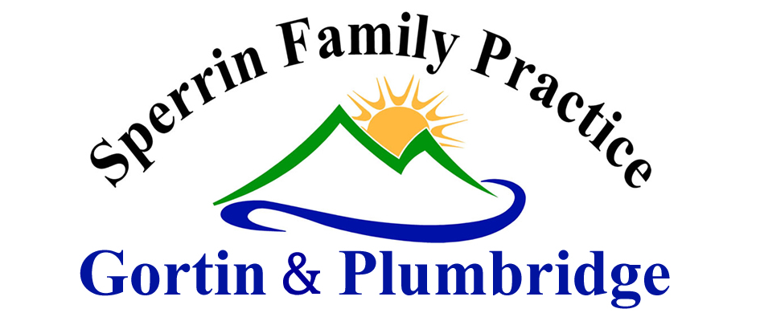
DR D MCAULEY

NEW PATIENT REGISTRATION INFORMATION FORM

It is not possible to undertake medical care without collecting and processing personal and health data. Information collected will be for specified, explicit and legitimate purposes only. Please see our Privacy statement (available from reception) for further details on what information we collect, how we process it and your rights as a patient.

Surname: ___________________________ First Name: _____________________________

Known as: __________________________ Birth Name: ____________________________

D.O.B: _____________________________ Place of Birth: __________________________
Marital Status (Mr, Mrs, Miss, Ms)
Address: ___________________________________________________________________________
______________________________________________ Postal Code: _____________________
Telephone Number: _____________________ Mobile Number: _____________________________
Do you consent to receiving text message(s) from the Practice Y/N (please circle)
E Mail address: _____________________________________________________________________
Preferred Pharmacy: ________________________________________________________________
Dispensing (Plumbridge only - (DP1 Form completed) ______________
Height ______________ Weight __________________
Smoking: Current/Never/Ex Smoker Alcohol: Units per week ________ per day _______ Beer/Spirits/Wine/Other __________________________
Blood Pressure (if known): _________ Date of last smear: ____________
Allergies: __________________________________________________________________________
Medication: _______________________________________________________________________

Do you consent to your patient held information being collected anonymously for use in research? (THIN- The Health Improvement Network) | YES/NO
Do you care for a family member?  - If you have answered ‘yes’ to the above question, as a new patient to the Practice, please make an appointment for an assessment of your needs as a carer. | YES/NO
Do you have a hearing difficulty? Yes/No
  - Are you a sign language user?
  - If Yes do you use BSL (British Sign Language) or BSL/ISL
ISL (Irish Sign Language)
- Preferred method of communicatiom _______________

Do your suffer from any visual or other physical Yes/No
difficulty (Give details on back of form)

Signature: __________________________________ Date: ________________________

